CM2020 Agile Software Projects – Final report

**SpaceWise**

A web-based seat and study room reservation system for libraries and co-working spaces

Authors: Jones Ullagaddi, Zachary Brown, Indu Singh, Roy Mattar

Revision: 01

University of London

BSc (Computer Science)

2024 Team11 Tutor Group 5

Table of Contents

Abstract 3

Outcome 3

Introduction 3

Planning and Research 4

Resource and time allocation 4

**Table of Figures**

Figure 1 Welcome to SpaceWise Screen 6

# Abstract

This project is a tool which allows users to reserve their library seat. This tool runs as app for anyone with a Phone / Tablet / Laptop. Users will choose a nick name (instead of real name). Users then book their library seat reservation in their city library branch (any library branch seat in their city). While allowing the user to book (or cancel their booking) the seat, the user also has restriction of 3 bookings per day.

Anyone can use this app. Library administrators can delete the User if they find multiple accounts by the same user.

# Outcome

The goal is to have an app instead of current paper based booking. The app provides freedom to book the seat. The user can be anywhere and book their seat. The user can use any device and book their seat. Users can also use any other device to cancel their seat. Users can choose any nick name of their choice. Users or Administrators can cancel the nick name. The number of user is not limited. Having said about the freedom and unlimited use; each device can book 6 users.

# Introduction

This app is developed by team of developers. There is front end developer; There is also backend developer with one full stack developer. The back end team will focus on the database, and main operational work area for the running the algorithms / database / test tools / profilers / Query managers.

The front end team will focus on how the data is presented to the users. User’s perception of the application. User judgment of data. User handling of data, Some users may prefer to use their phone while other users may want to use their laptop.

How users will receive the data. How users will respond to data. Will the users be quiet to themselves (without providing feedback) or users will try to over active.

What kind of color the users presented. The type of font used by the users. User preferences of using the application for themselves or for the group of friends with password sharing.

These are few questions to be monitored by the administrators. Is provides valuable feedback to the administrators as well as the app developers. The behaviors of the individual users very good and valuable information. These are few functionalities the front end developers can use.

# Planning and Research

## Resource and time allocation

Front end and back end teams work concurrently to develop the application. There will be constant information exchange between front end team and back end team. The university has provided very good communication tool call Slack. Slack is used for every communication between the developers (frontend as well as backend).

The first two weeks were used by the team to get familiar with the tools / libraries / protocols / APIs. The team also spent time in knowing the capabilities of the tools. Some users were not familiar with the tools. The first two weeks used to get familiar the tool.

Though the first half of semester was used for the research; The first half of the semester mainly concentrated on market research, project options, project reasoning, project selection etc.

## Frontend

Front end mainly concentrated on the dealing with end users. This involved

Type of frontend

Tool used for the frontend

Size of every single screen

Color scheme used for the user interface

Font used for the front end

Sequence of the screens

Logic behind the screen

### Type of frontend

This part of section deals with what kind of frontend selected. To be specific frontend planned to work in windows environment (windows 7 , windows 10 , windows 11). Frontend planned to work in Linux environment. And front end also planned to work with Apple Macintosh.

### Tools used for the front end

Tools were carefully selected to keep the system small and efficient.

React front end with Tailwind CSS

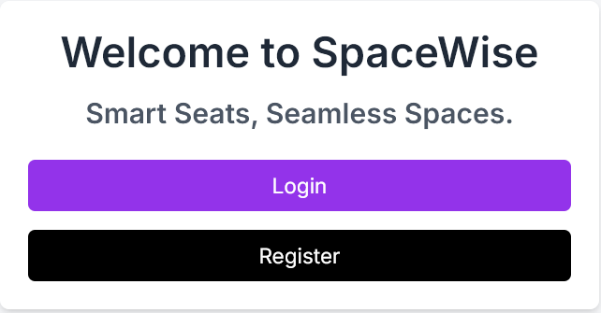

Figure Welcome to SpaceWise Screen

Welcome to SpaceWise Screen

A sample screen which shows the use of tailwind / React front end